**Practical 11 (Deadline 26th July 1159pm)**

**Network Applications and Configurations**

1. TCP/IP and Network Commands
2. Email Overview
3. Managing Network Interfaces
4. Basic IP Routing and Gateways
5. **TCP/IP and Network Commands**
6. View the “/etc/services” file by typing: cat /etc/services

What is the port number for the “smtp” service?

|  |
| --- |
| 25 |

1. Show the result page by page by typing: more /etc/services

( **PIPE** the output of cat command to MORE, Jump the page one at a time by SPACEBAR)

1. search the result AUTOMATICALLY by typing cat /etc/services | grep smtp

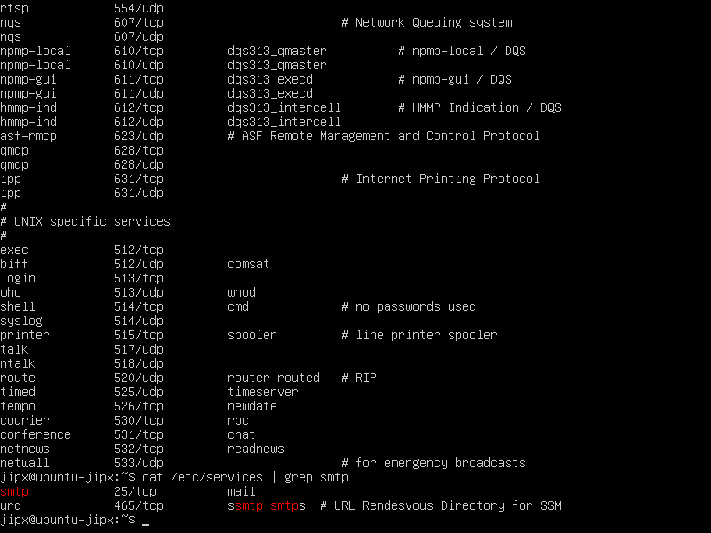

1. Output the result to a text file “resultSmtp.txt”

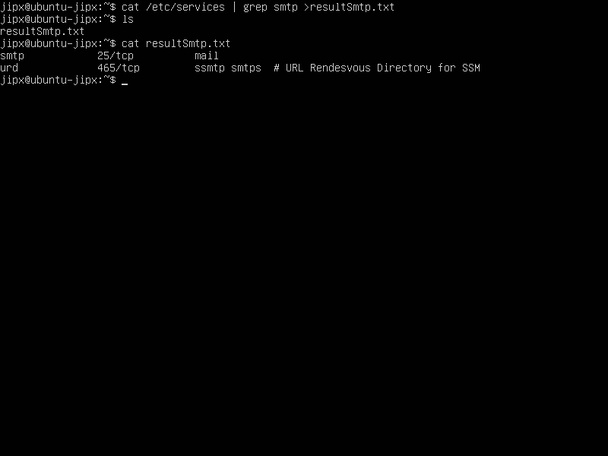

1. How many services related to SMTP?   
   wc -l resultSmtp.txt

Write a single command to get the result.

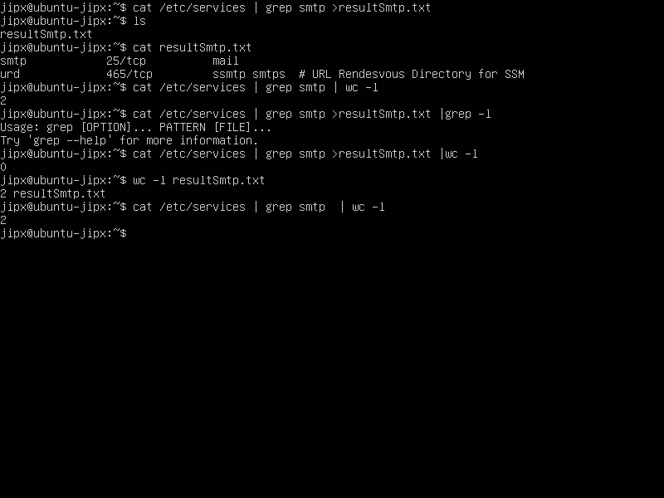

|  |
| --- |
| **please delete the temporary file generated “resultSmtp.txt”  To remove (or delete) a file or directory in Linux from the command line, use the rm (remove) command. Be extra careful when removing files or directories with the rm command, because once the file is deleted it cannot be recovered.** |

1. Type netstat –tuna to list all Ports (tcp and udp) that are opened are listed as “LISTEN”. (netstat -tuna | grep LISTEN)

|  |
| --- |
|  |

1. Write a single command to get the total number of ports opened.

(netstat -tuna | grep LISTEN | wc -l)

|  |
| --- |
| 4 |

1. Type ifconfig to display your machine’s IP address.

You should get a display similar to that shown below. This command allows you to find out the IP address & MAC address of your various network interfaces on your server.

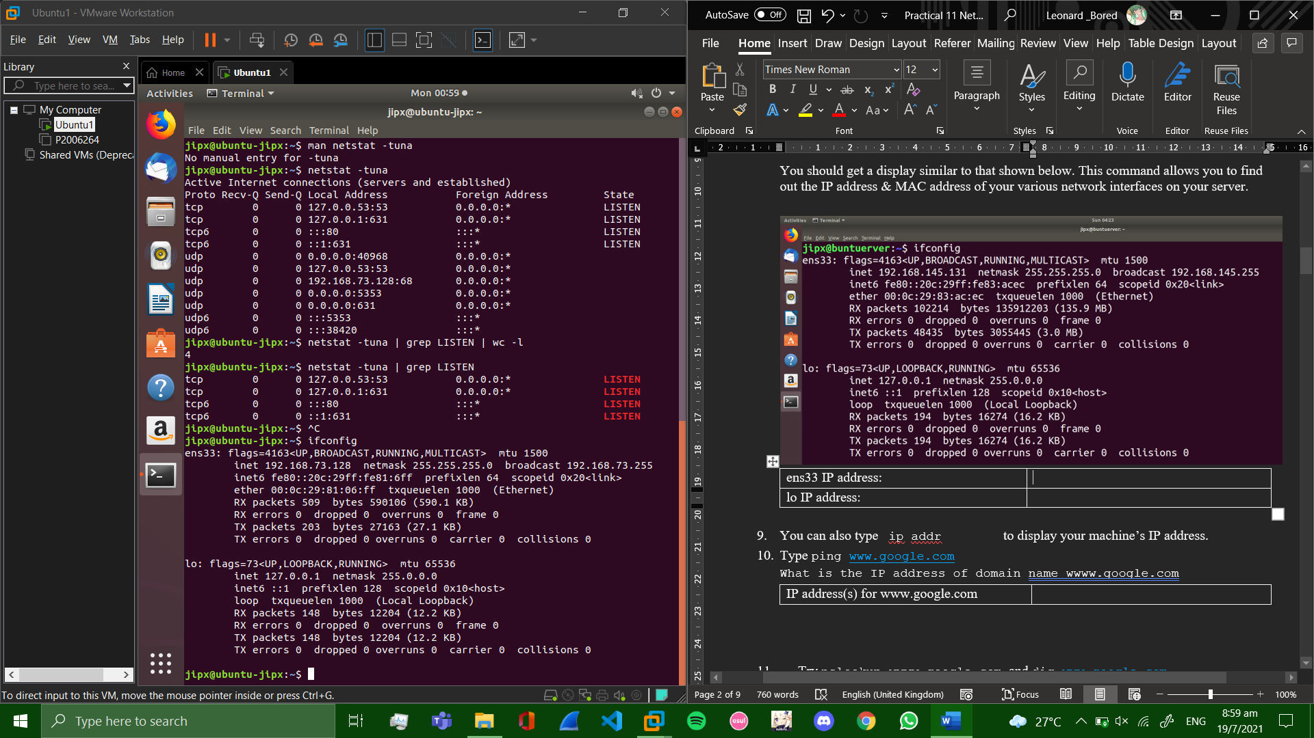

|  |  |
| --- | --- |
| ens33 IP address: | 192.168.73.128 |
| lo IP address: | **127.0.0.1** |

1. You can also type ip addr to display your machine’s IP address.
2. Type ping [www.google.com](http://www.google.com)

(ctrl + z to stop pinging) (ctrl + c to stop and give stats)

What is the IP address of domain name wwww.google.com

|  |  |
| --- | --- |
| IP address(s) for www.google.com | 74.125.200.103 |

1. Try nslookup wwww.google.com, and dig [www.google.com](http://www.google.com)

You should see response similar to the shown below.

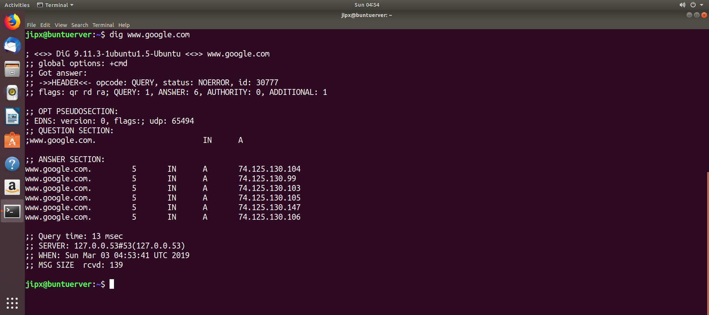

Record down the DNS server IP address and port number

|  |  |
| --- | --- |
| DNS server IP | 127.0.0.53 |
| DNS server viPORT | 53 |

1. Type vi /etc/resolv.conf to verify the DNS server name in the file: /etc/resolv.conf (Feel free to replace vi with nano)

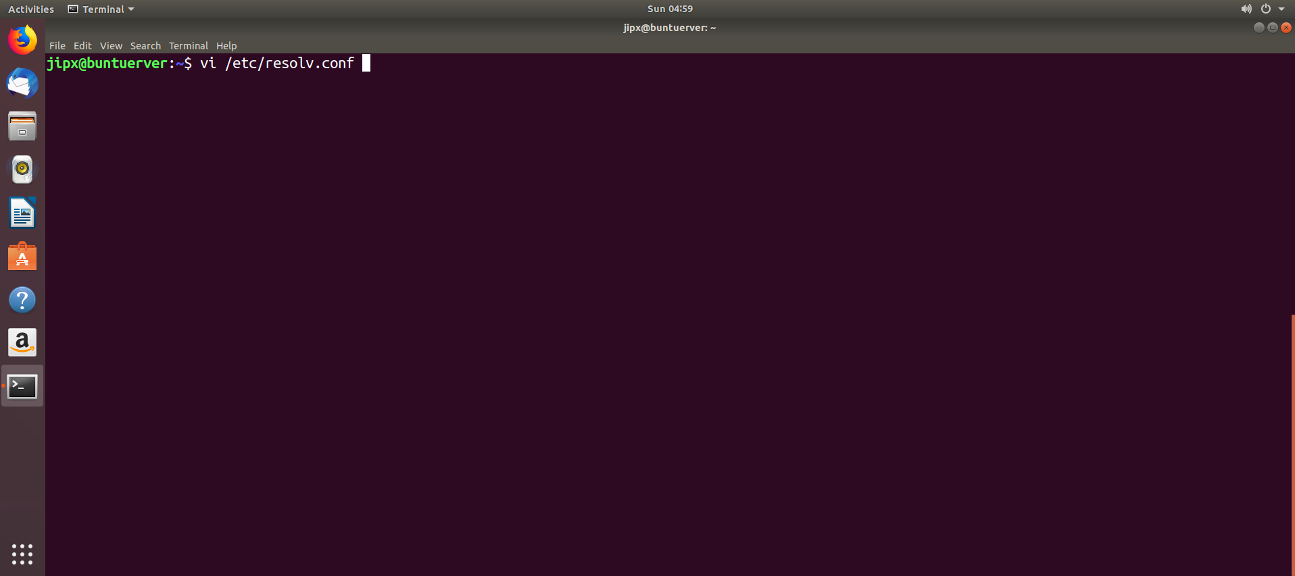

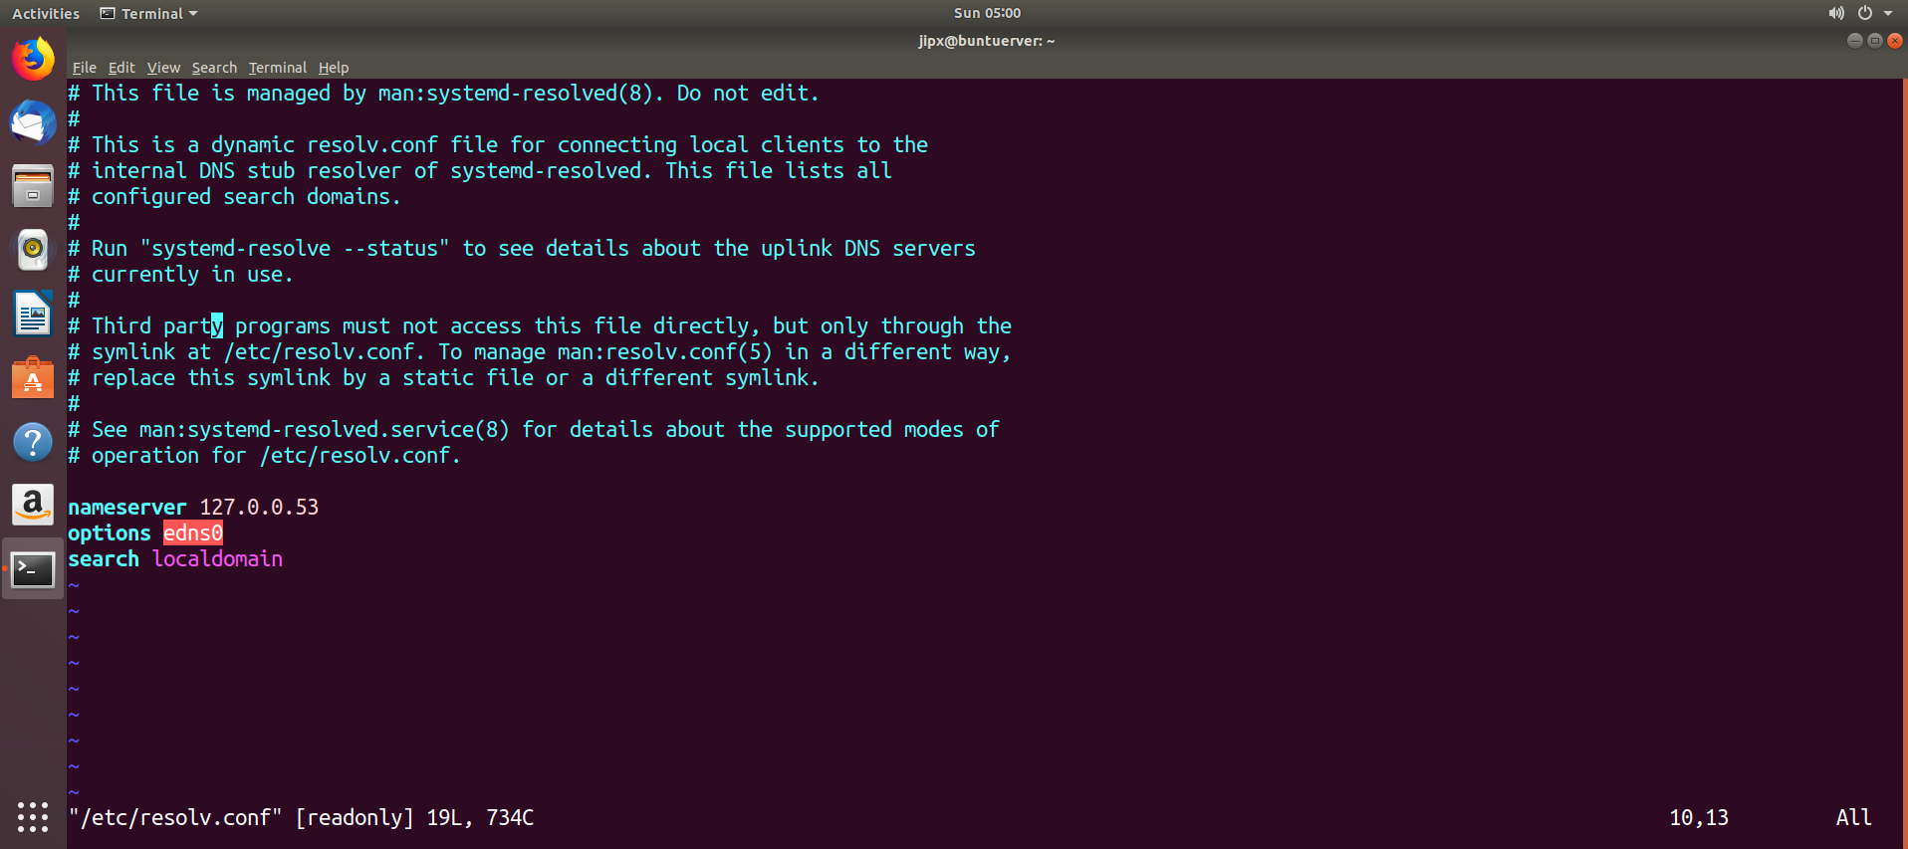

1. Ping your physical Windows 10 machine
   * + 1. Type ping your_physical_Windows10_IP_address
2. **Change your host name** 
   1. Press Ctrl+Alt+T on keyboard to open the terminal. When it opens, run the below command:

hostname

* 1. To change the name permanently, run command to edit the host files:

For Ubuntu server without a GUI, run sudo vi /etc/hostname and sudo vi /etc/hosts and edit them one by one.

In both files, change the name to what you want and save them.

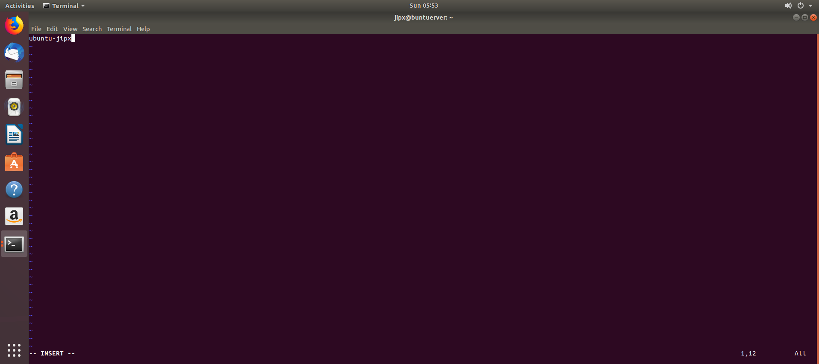

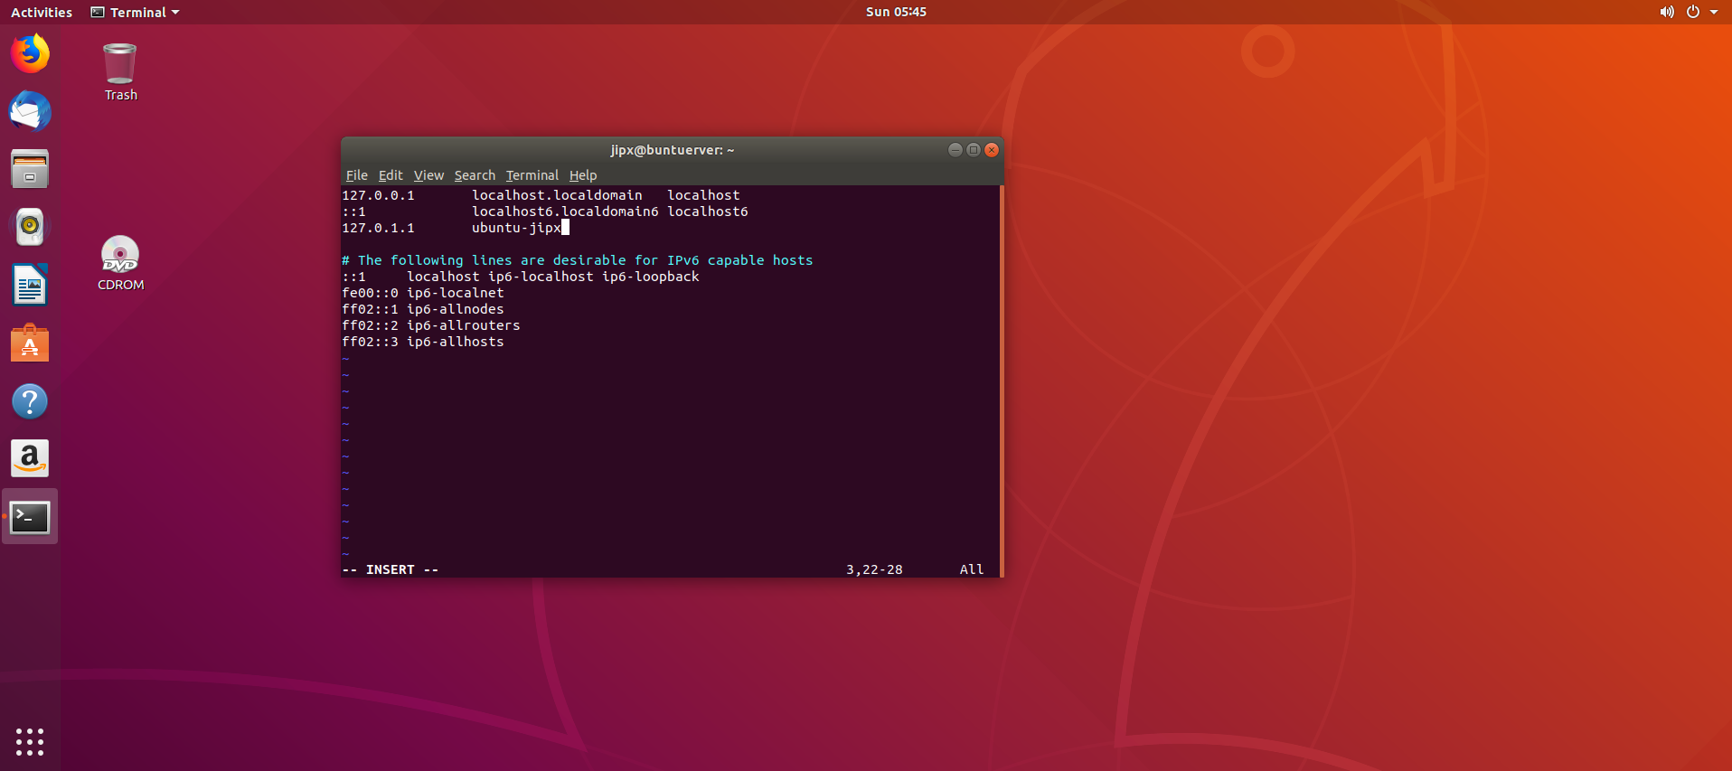

* 1. Edit the file /etc/netplan/50-cloud-init.yaml and add in the following line:

renderer: NetworkManager

Type sudo gedit /etc/netplan/50-cloud-init.yaml

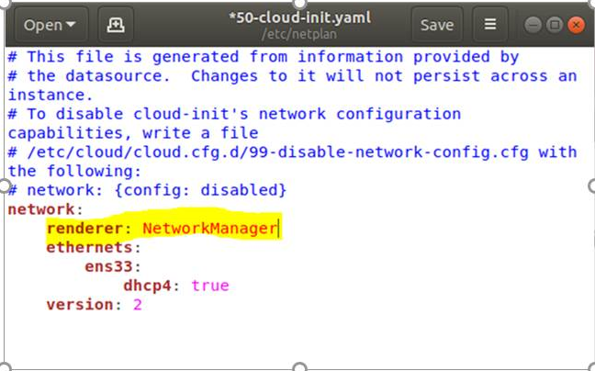

* 1. Run sudo netplan to apply, to effect the change

Type sudo netplan apply

* 1. Restart your Ubuntu VM.
  2. Type cat /etc/hosts  
      cat /etc/hostname  
     You will notice that the settings have been changed.
  3. Type hostnameto reconfirm that the computer name has indeed changed.

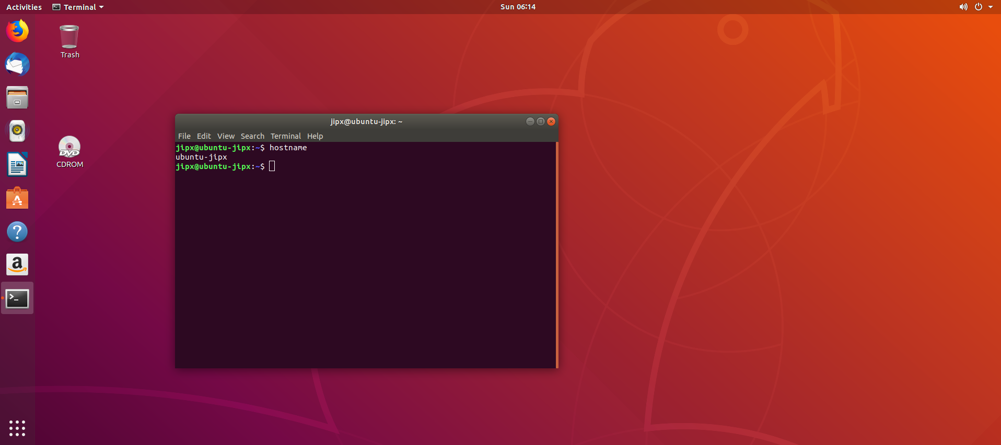

* 1. Type hostnamectlto reconfirm that the computer name has indeed changed.

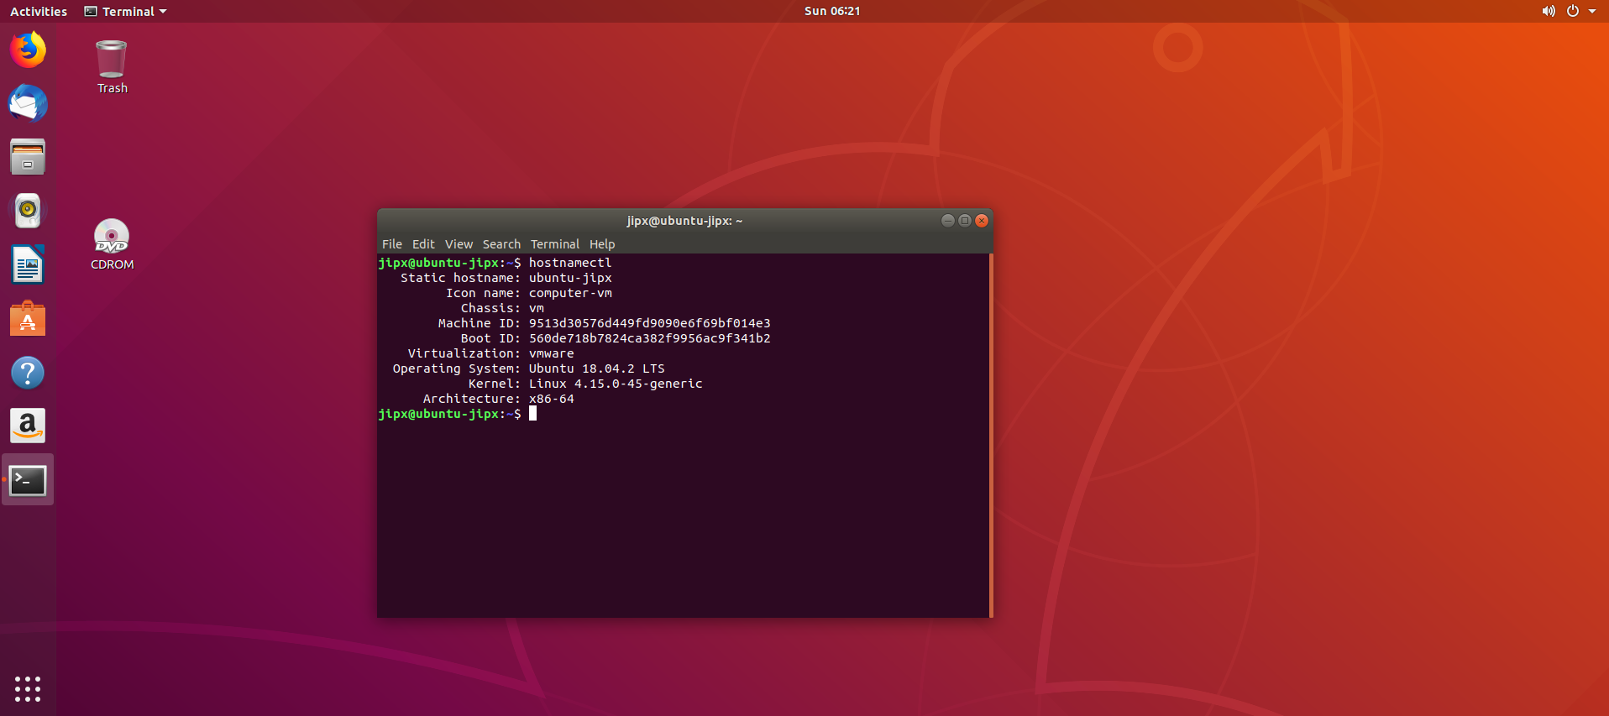

1. **Basic IP Routing and Gateways (make sure firewall is open)**
2. Ping to another machine e.g. ping www.google.com
3. Type arp -a to view the ARP cache. Can you find the MAC address of gateway?

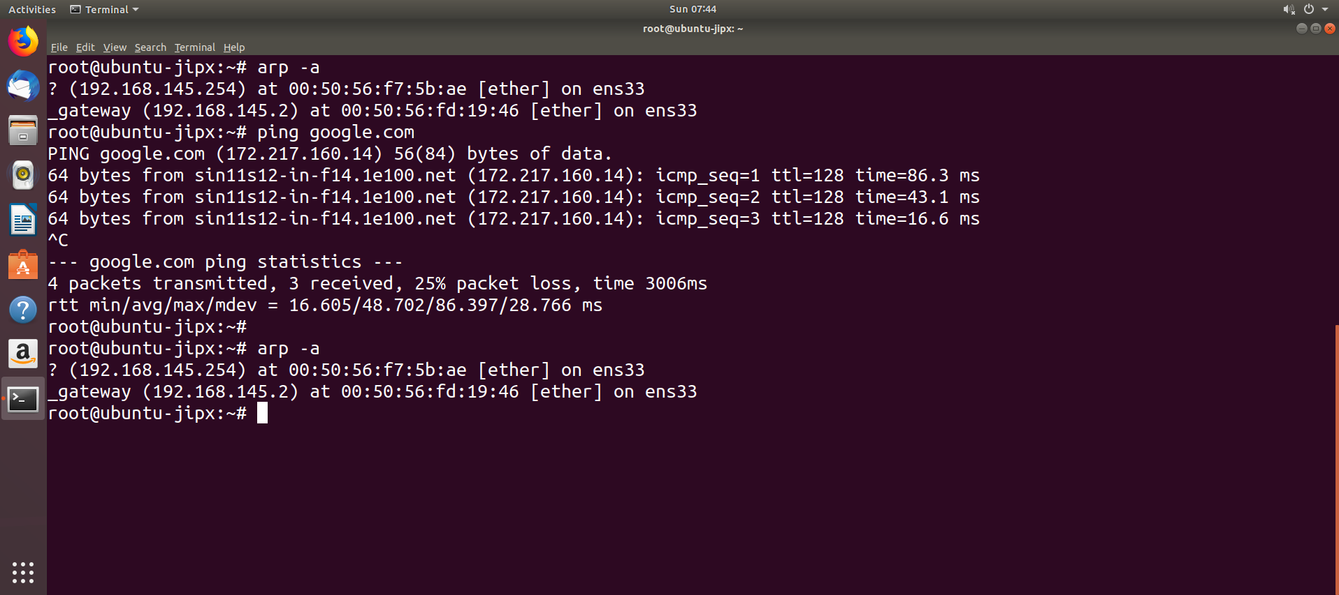

|  |  |
| --- | --- |
| MAC address of your gateway | 00:50:56:ef:71:0c |

1. Type ip route to view the current routing table.  
   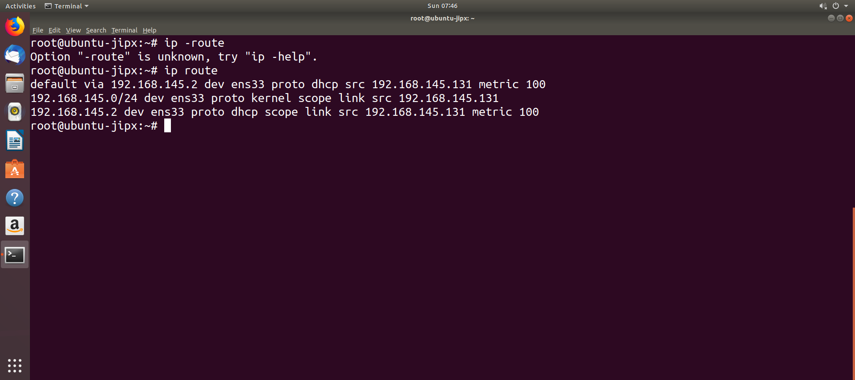
2. **Email Overview (SKIP part D on email)**
   1. As user student, send an email to root.

mail root

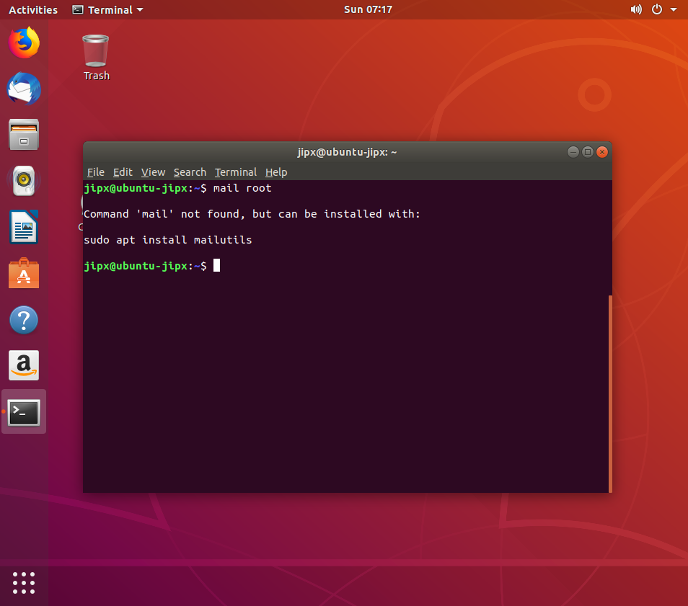

If mailutils not installed, you will see the above error.

**Type: sudo apt install mailutils**

Press **<tab>** key (cursor will be moved to “Ok”). Press the **<enter>** key.

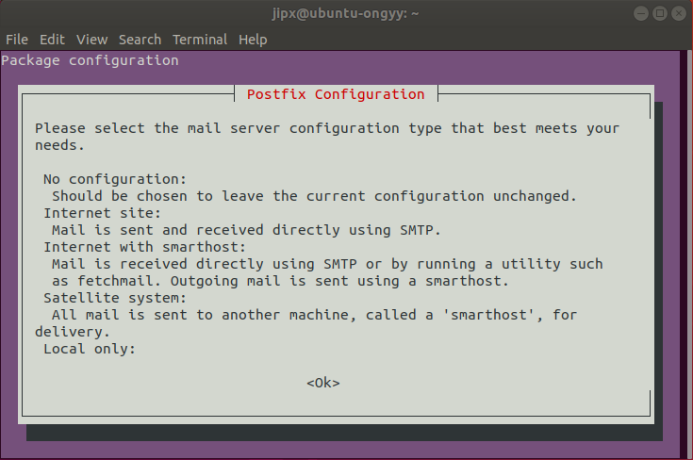

Select Internet Site & Ok (use <tab> key). Press the **<enter>** key.

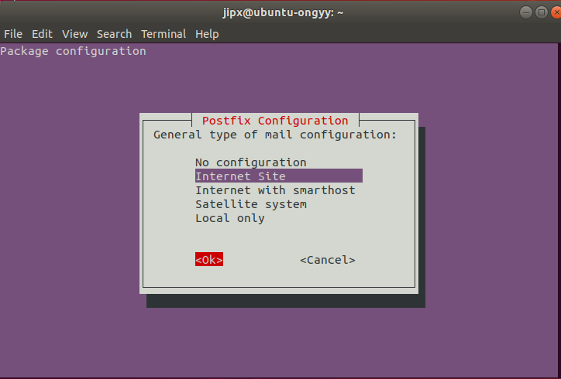

After installation, type mail root again.

* 1. Type in a subject and press <enter>
  2. Type in the mail message. When you have completed typing the mail message, press <Control-D> to end the message.

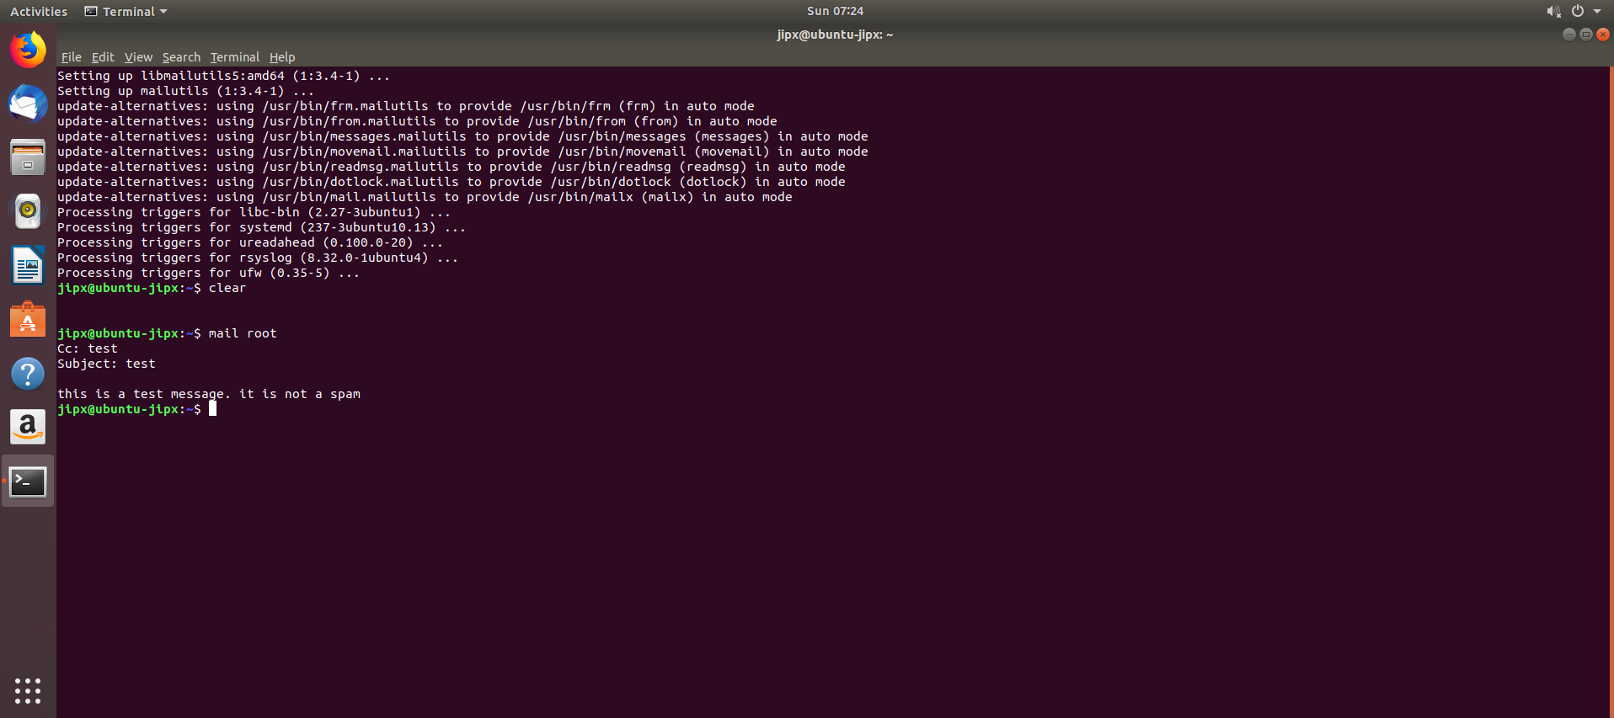

if you see error: “*mail: cannot send message: process exited with a non-zero status”*: please refer to troubleshooting

* 1. As user root, type mail

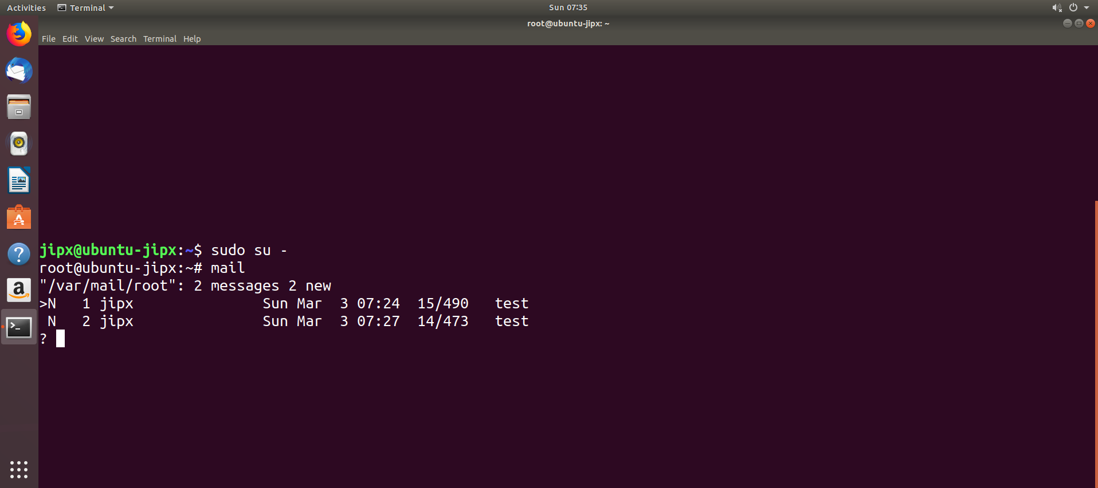

A list of mail will be displayed.

* 1. Type <number> to read mail, where <number> is the number of the mail you wish to read.

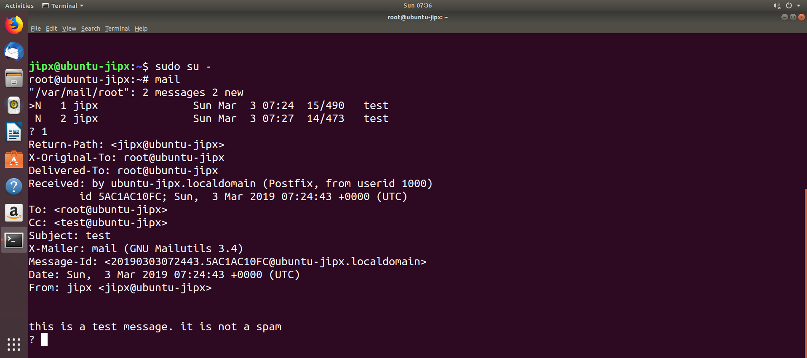

* 1. Type s to save the read mail to mbox.
  2. Type h to view the mail headers.

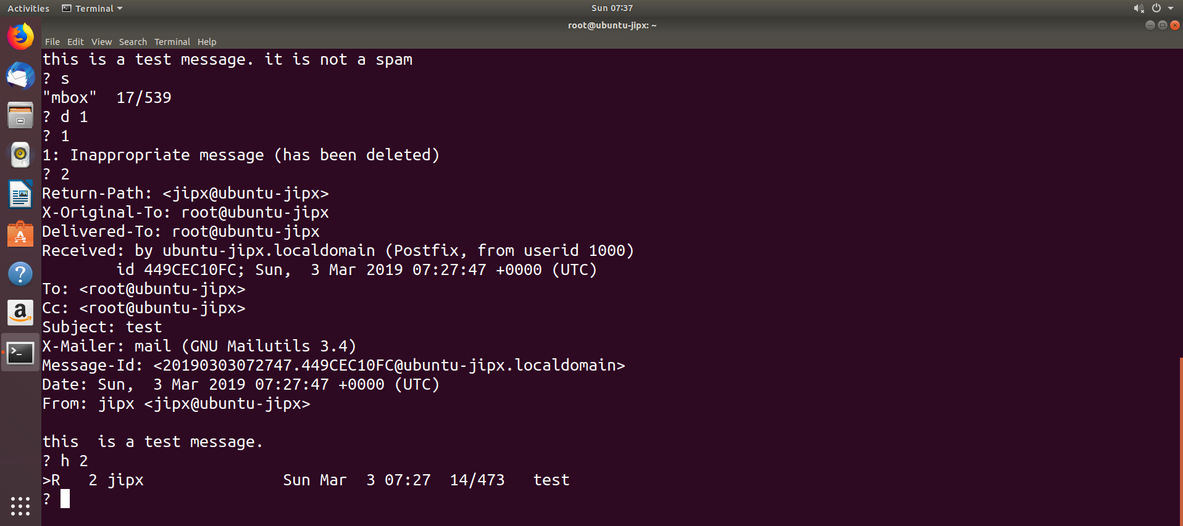

* 1. To delete mails, type d <number> , where <number> is the number of the mail to be deleted.
  2. Type q to quit the “mail” program.

**TroubleShooting**

|  |
| --- |
| *mail: cannot send message: process exited with a non-zero status  (1) Check the error log  sudo cat /var/log/mail.err  which said:*  *postfix/sendmail[27115]: fatal: open /etc/postfix/main.cf: No such file or directory*  *(2)*  *sudo dpkg-reconfigure postfix*  *source:* [*https://unix.stackexchange.com/questions/185365/mail-cannot-send-message-process-exited-with-a-non-zero-status*](https://unix.stackexchange.com/questions/185365/mail-cannot-send-message-process-exited-with-a-non-zero-status) |

*End of Practical*

* 1. What have you learnt?

Today, I have learnt more about pinging and network application in the terminal of linux unbuntu. Such commands as ping can also be done in the command prompt of the windows but it continues to ping in linux until u tell it to stop with ctrl + z or ctrl + c for stats.

2. Difficulties encountered and how you solved the problems?

Generally, there were no difficulties with this practical. Everything was straight forward and was thoroughly explained by my lecturer